Drvr User Manual

Kapil Haresh

**Shien Wee Ng**

**Dyalan Shanmugarajah**

Hui Jia Yeoh

Version Updates:

|  |  |  |  |
| --- | --- | --- | --- |
| **Version** | **Changes made by** | **Changes made** | **Date** |
| 1.0 | Hui Jia Yeoh | * Added Overview, Objectives, Installation (incomplete). * Inserted Infographics, Simulation, Quiz section. Images used were mock ups done by Kapil. * Infographics guide added but with no suitable screens to add. The same thing goes for quiz | 30-4-2015 |
| 2.0 | Hui Jia Yeoh | * Updated Infographics and Quiz content according to the meeting held on 1-5-2015. * Added version updates section to keep track of changes made when, where and by whom. | 2-5-2015 |
|  |  |  |  |
|  |  |  |  |

# **Overview**

Ever wondered how much you know about your car and how it works on the inside? Let Drvr take you through an immersive learning experience to further develop your knowledge on the four wheel automobile you have been or will be driving!

Drvr’s three components will take you on a drive on the learning lane, allowing you to experience informative infographics, interactive systems simulation and challenging quizzes to enhance your understanding on how a car works.

# **Objectives**

Drvr has the following objectives:

* To produce informed users by polishing/improving their knowledge on cars
* To allow users to understand how the components in the car interact.
* To allow users to put the knowledge they have acquired to test.

# **Installation**

* Run the setup file that comes with this manual.
* [Include images to allow user to follow instructions]

# **Introducing Drvr**

[Insert Drvr main menu here]

## **Learning with Infographics**

Choosing the Infographics option from the main menu will bring you to a screen as shown in figure 1. The infographics will allow you to learn through brief descriptions, highlighted parts of the car and video links.

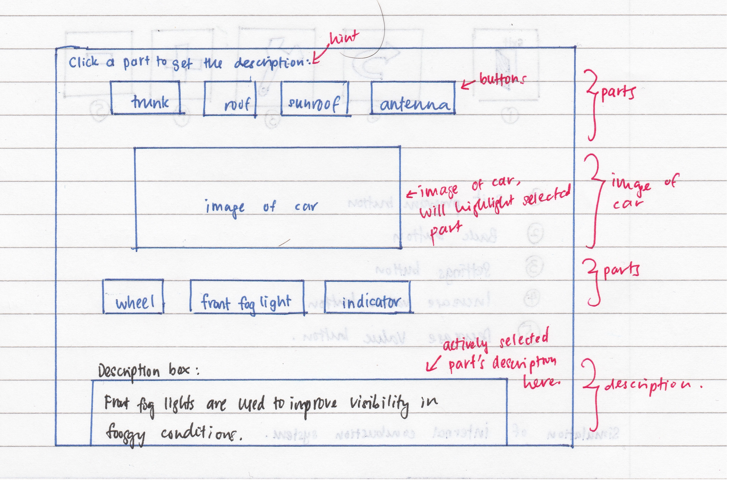

Figure 1: Infographics main screen

### VIEW

* You will be able to see different parts and views of the car by clicking on either the left or right arrow that cycles through the ‘Front’, ‘Rear’, ‘Side’, ‘Top and ‘Interior’ view of the car.
* Choosing the up or down arrow will take you to a zoomed in or out perspective of the car of the view you have chosen.

### COMPONENTS LIST

* You will be able to select any component listed in this list to learn more about it. Description of the part can be found in the description box below the image.
* The component that you have selected will be highlighted on the car.
* In addition, you will also be able to click on any part of the car to learn more about it. The description of the part will be shown in the description box below the image and the respective component name will be highlighted.

### DESCRIPTION BOX

* The description of the selected part will be appear here.
* Besides that, there will be a button that links to a YouTube video for some parts to further describe the selected component. A pop up window will appear for this video to play as shown in figure [x].

### HOME

* This button will bring you back to the main menu- click if you wish to return to the main menu and leave the Infographics page.

## **Understanding with Simulation**

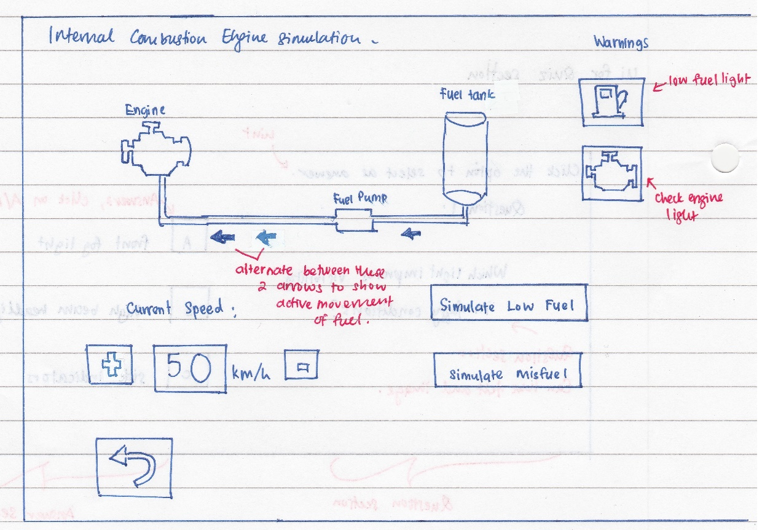

Figure 2: An internal combustion engine simulation under ‘Simulation’

## **Test yourself with the Quiz**

The quiz segment will test you on how well you have understood the car systems from the infographics and simulation part. Selecting the option to take the quiz will take you to a page containing the quiz instructions as shown below: [Insert image of quiz instruction page]

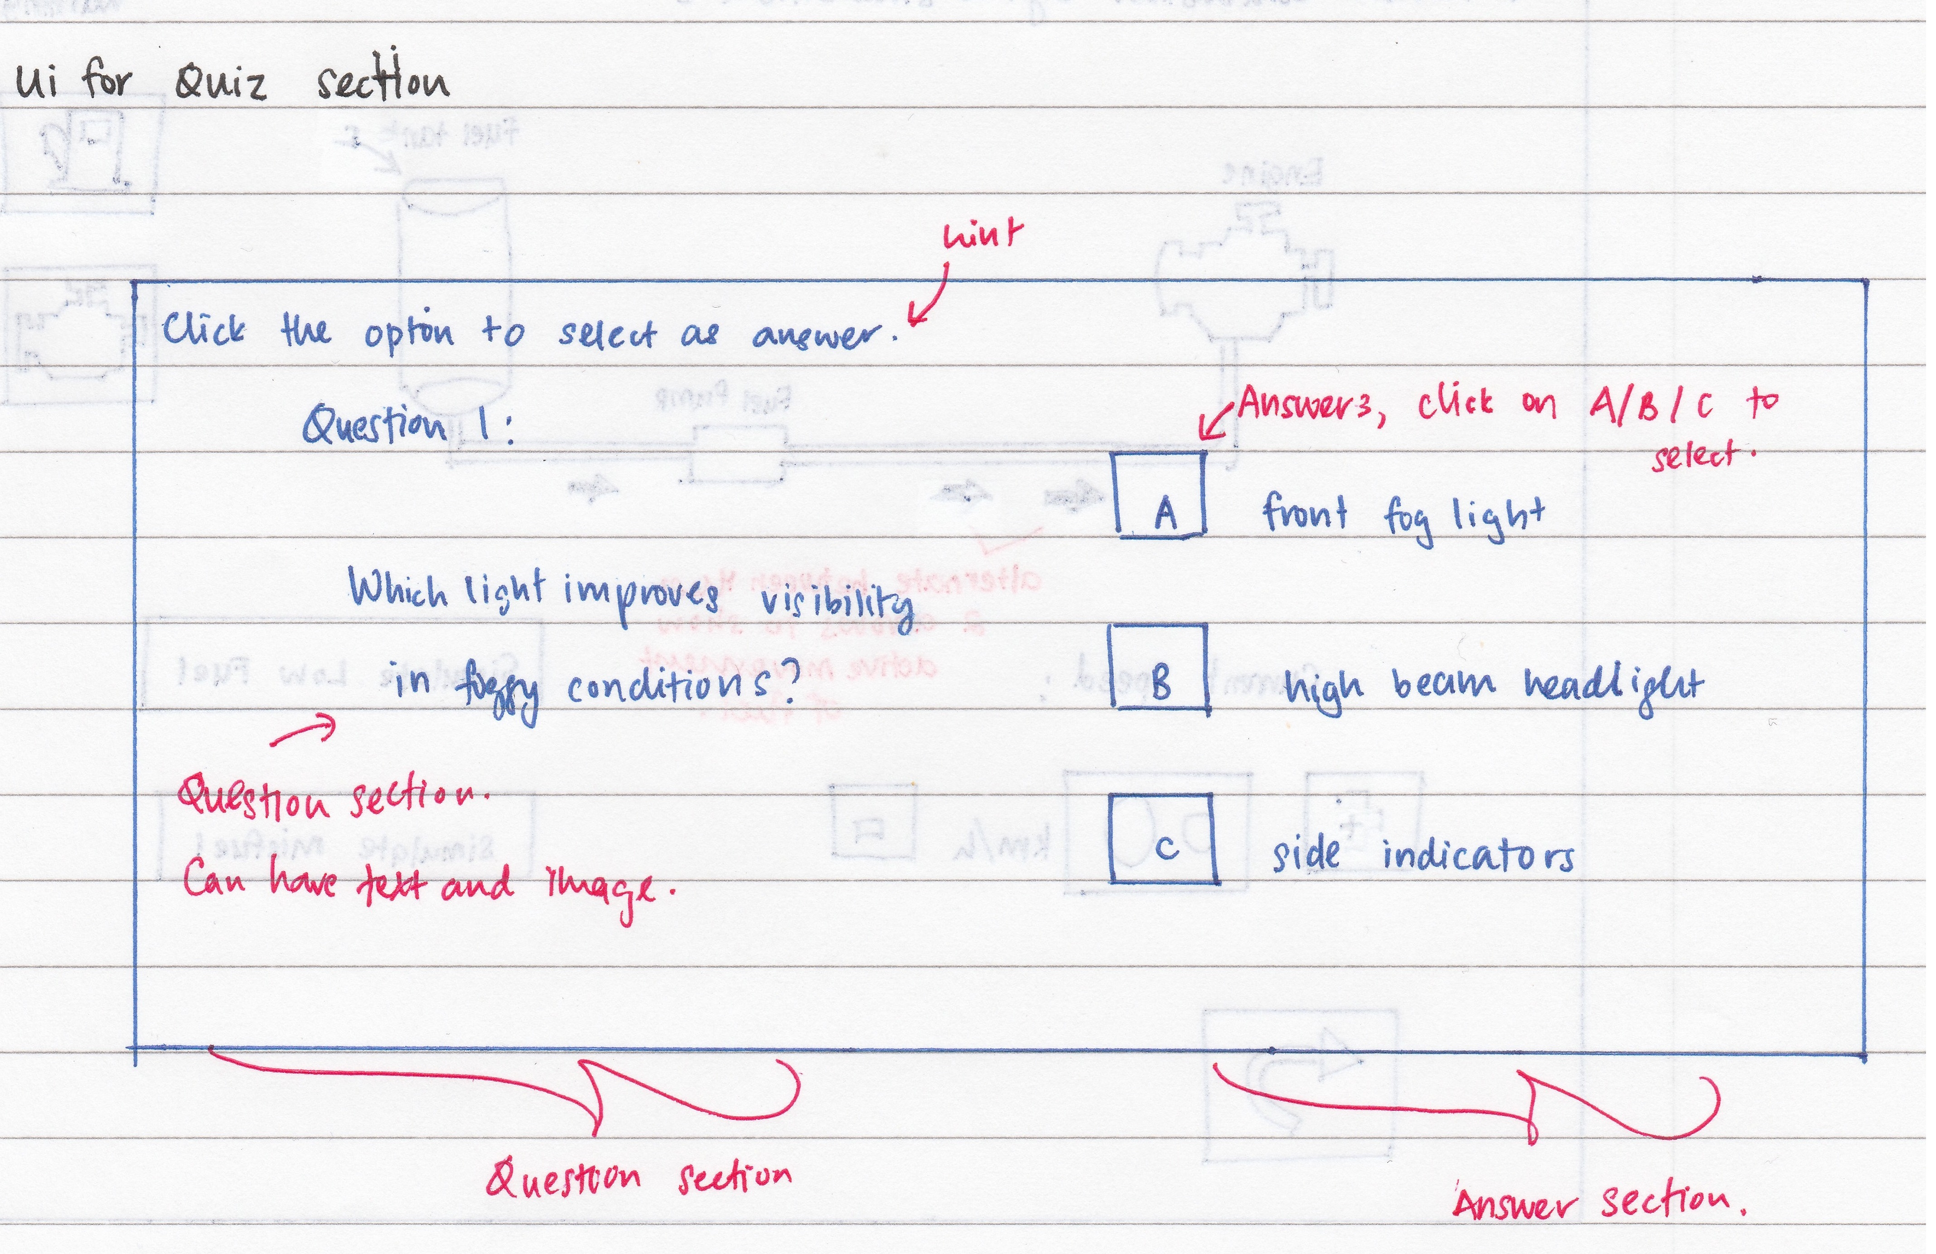

Figure 3: An example of the quiz question

## During the quiz

* A series of questions will be provided to you and you will be required to answer them within 10 minutes.
* The segment on the left will be where the question will be while the segment on the right will be where the answers are, as shown in Figure 3.
* Answers can be selected using the keyboard in accordance to the number for the question (e.g. pressing ‘1’ for answer ‘1’). Pressing ‘Enter’ will submit that answer for the question and will move on to the next question.
* Questions can be in the form of text or image and you will be required to select the most befitting answer from the answer section.
* You are free to answer the questions in any particular order.
* You are allowed to abort the quiz midway but no statistics will be recorded and upon starting the quiz again, you will have to begin from the start once more.

## Results

* After all questions have been answered, a final page showing you the summary of your progress through the quiz, including number of questions answered and unanswered.
* You will then obtain your results after registering your confirmed answers as shown in the figure below: [WARNING: You will not be able to change your answer after submitting your answers after this page].

**[Insert end page image]**

* You are able to review the questions that you have answered to find out which ones you have gotten right or wrong. Questions which are right are highlighted in ‘green’ while answers which are wrong are highlighted in ‘red’.
* When reviewing an incorrect question, answers highlighted in ‘yellow’ are the answers you have chosen while those highlighted in ‘’ are the correct ones.
* Answers are highlighted ‘green’ when reviewing questions you have answered correctly.
* Exiting from here will return you to the main menu once more.